

**Report:**

**Regional First Aid Meeting for the Pacific**



# **Introduction**

# The First Aid Regional Meeting, held on 24 May 2025 in Nadi, Fiji, brought together newly certified First Aid Trainers of Trainers (ToTs) from across the Pacific. Organized by French Red Cross - Preparedness and Response Platform for the Pacific (PIROPS) in close collaboration with the IFRC Global First Aid Reference Centre (GFARC) and the IFRC Country Cluster Delegation for the Pacific, and funded by the Agence Française de Développement as part of Project 3 Oceans, the meeting aimed to strengthen the regional First Aid programme by investing in the knowledge and leadership capacity of new ToTs.

# 

# **Meeting objectives**

The meeting aimed to:

* Enhance participants’ understanding of regional First Aid challenges and opportunities, including the importance of contextualizing training materials and approaches to fit local cultural, environmental, and social realities;
* Introduce strategic and business-oriented thinking for sustainable Commercial First Aid programming;
* Improve communication and marketing capacities among trainers to support outreach, visibility, and professionalism;
* Provide participants with a deeper understanding of the IFRC First Aid Vision 2030 and global approaches to First Aid, ensuring alignment with international standards and strategic priorities;
* Co-create a Regional Action Plan to guide the development and expansion of First Aid programmes across the Pacific.



# **Participants**

This meeting gathered newly certified Trainers of Trainers (ToTs) from National Red Cross Societies across the Pacific region. Participants represented the Red Cross Societies of Fiji, Kiribati, Samoa, Solomon Islands, Tonga, Tuvalu, and Vanuatu, many of whom are actively engaged through the “3 Oceans” project. In addition, colleagues from the Red Cross Societies of Australia, Cook Islands, New Zealand, and Papua New Guinea also joined the workshop, contributing valuable perspectives and strengthening regional exchange and collaboration.

The event was further enriched by the presence of GFARC Master Educators, along with facilitators and technical staff from PIROPS/GFARC, the IFRC CCD Office in Suva, and the Fiji Red Cross Society.

This diverse group brought together a broad spectrum of experience, expertise, and regional insight, fostering a collaborative environment for learning and joint planning.

**Summary of Meeting Sessions**

**Session 1: Contextualization and Regional Coordination**

Facilitator: Jasmin Niksic, First Aid Delegate, PIROPS/GFARC

This session emphasized the importance of adapting First Aid training materials to the cultural, environmental, and social contexts of Pacific communities. Participants were introduced to the Pacific Technical First Aid Working Group as a key mechanism for peer learning, technical alignment, and regional coordination.

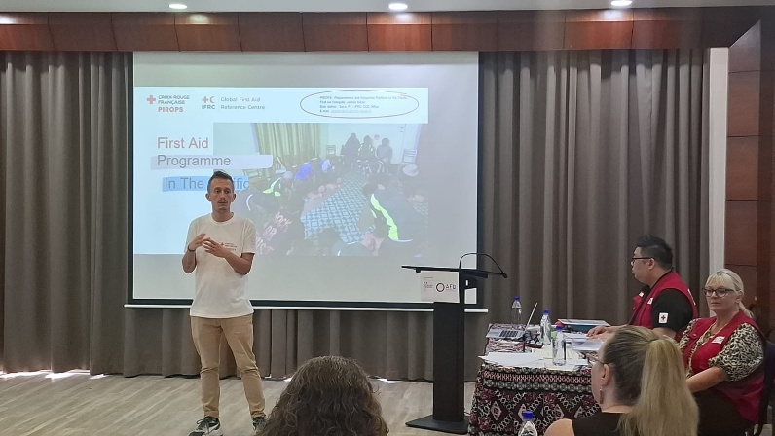Additionally, the IFRC First Aid Vision 2023 was presented, highlighting the global commitment to:

* Integrating First Aid into schools and community-level education;
* Strengthening the role of Commercial First Aid as a sustainable funding stream;
* Promoting First Aid as a life skill;
* Encouraging evidence-based training and continuous education for trainers.

This strategic vision helped participants contextualize their national efforts within broader global priorities and reinforced the importance of alignment across National Societies.

**Session 2: Commercial First Aid**

Facilitator: Amelia Baro, Business Development Manager, IFRC CCD Suva office

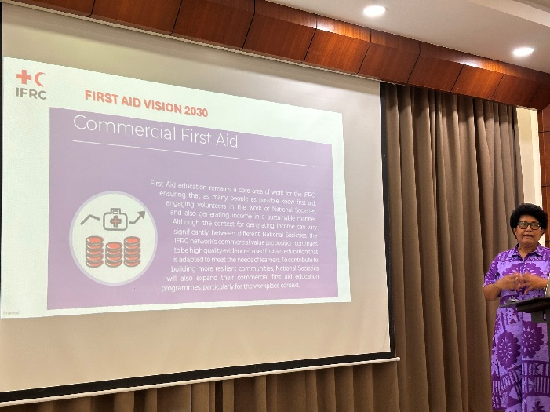This session focused on building participants’ understanding of the strategic importance of Commercial First Aid as a core component of sustainable First Aid programming. The main topic of discussion was the role that First Aid instructors play in the development and expansion of Commercial First Aid. The presentation and discussions were directly aligned with the IFRC Strategy 2030 and the IFRC First Aid Vision 2023, both of which emphasize the need for innovative, quality-driven, and financially viable approaches to delivering lifesaving education.

The session highlighted that Commercial First Aid is not only a source of income but also a means of expanding reach, visibility, and public trust in Red Cross services.

Strong emphasis was placed on ensuring that Commercial First Aid offerings are:

* High in quality – delivered by well-trained, confident instructors using standardized and contextually adapted materials;
* Trustworthy – building on the Red Cross reputation to assure clients of professionalism and reliability;
* Relevant – tailored to the needs of various sectors (corporate, schools, workplaces, remote areas), with practical, culturally appropriate scenarios.

Group work enabled participants to analyze their National Society’s current commercial approach and brainstorm ideas for improving services. Overall, the session served as both a practical and strategic exploration of how Commercial First Aid can help National Societies enhance their humanitarian mission while building long-term program sustainability.



**Session 3: Communication and Marketing**

Facilitator: Luisa Turaga, Marketing & Communications Manager, Fiji Red Cross Society

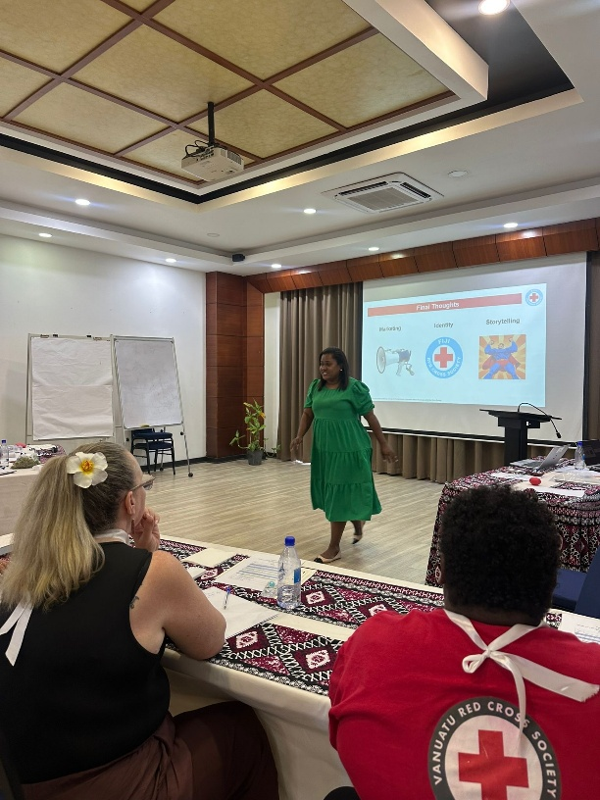Participants gained new knowledge and understanding of why communication and marketing are essential for the success of both community-based and commercial First Aid programmes. Special focus was placed on strategies to reach diverse target groups, including schools, workplaces, and the private sector, using digital platforms such as social media.

Participants engaged in practical exercises to create campaign messages and explore tools for visual storytelling. Emphasis was placed on the critical role of quality photography and reporting in promoting the image of the Red Cross and the visibility of First Aid courses.

Trainers of Trainers were reminded that they also serve as communicators. They need to:

* Document success stories and impactful moments;
* Provide concise and engaging reports and quality photos;
* Work closely with their NS teams to ensure alignment with brand and strategy.

This contributes not only to raising public awareness but also to positioning First Aid as a credible, high-quality service and strengthens the visibility and reputation of the Red Cross in the eyes of partners and communities.



**Outcomes**

Participants discussed practical ways to improve their First Aid work, focusing on strategic planning and enhancing the quality and effectiveness of commercial First Aid services.

Through discussions and presentations, participants received more detailed information about the IFRC First Aid Vision 2023, including key global priorities such as:

* Integrating First Aid into schools and communities;
* Expanding Commercial First Aid as a sustainable pathway;
* Promoting First Aid as a universal life skill;
* Ensuring evidence-based and contextually relevant training.

This helped participants better understand the global approach within the Movement, while also identifying areas where local adaptation is critical for impact.

**Enhanced Regional Alignment:**

Participants agreed to engage regularly with the Pacific Technical First Aid Working Group to share resources, align methodologies, and collaborate on regional initiatives.

**New Strategic Knowledge:**

Tools and resources on commercial first aid were shared with participants, with a focus on strategic planning and commercial thinking.

**Strengthened Communication Capacity:**

Participants had an opportunity to learn more about how targeted communication and marketing can directly influence the reach and impact of First Aid services, particularly in the commercial context. This was also an ideal opportunity to explore how to recognize the importance of consistent, high-quality visual and written content in promoting courses to broader audiences, strengthening brand visibility and trust, attracting potential clients and partners, and showcasing the professionalism of Red Cross First Aid services

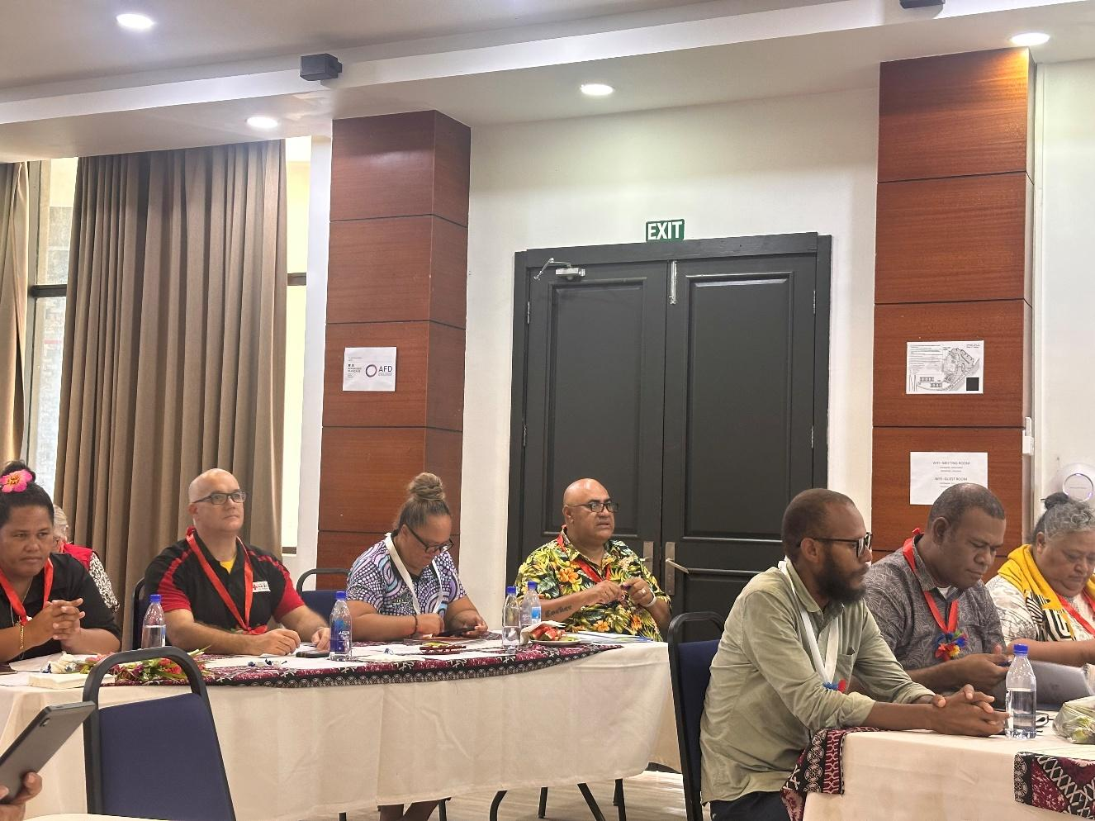

**Conclusion and Next Steps**

The First Aid Regional Meeting successfully strengthened the regional network of ToTs and laid the groundwork for more aligned, sustainable, and visible First Aid services. Joint commitments will serve as a guiding framework, supported by PIROPS, GFARC and IFRC CCD Suva office, for national follow-up activities and shared regional progress.

* **National-Level B First Aid Training Rollouts**

Over the next 6 to 8 months, newly trained Trainers of Trainers (ToTs) will lead national-level B First Aid training sessions. These will be conducted in close collaboration and support by First Aid Delegate, PIROPS, GFARC and IFRC CCD Suva office to ensure quality and consistency.

* **Integration into the Pacific Technical First Aid Working Group**

Newly trained ToTs will be integrated into the Pacific Technical First Aid Working Group to support the adaptation and contextualisation of First Aid materials to local contexts and needs.

* **Participation in Regional Coordination and Knowledge Sharing**

ToTs will actively participate in the Regional First Aid Monthly Meetings, promoting cross-country learning through the exchange of promotional materials, tools, and success stories among Pacific National Societies.

* **Ongoing Peer Exchange and Campaign Initiatives**

National Societies will maintain the momentum through regular peer exchanges, targeted First Aid campaigns, and the incorporation of strategic tools into their national programmes.

* **Implementation of Joint Regional Commitments**

The joint commitments agreed upon during the Regional Meeting will guide national follow-up actions. PIROPS, GFARC, and the IFRC CCD Suva office will provide ongoing support to ensure cohesive and measurable regional progress.

*Suva, June 2025.*