**Study on first aid training**

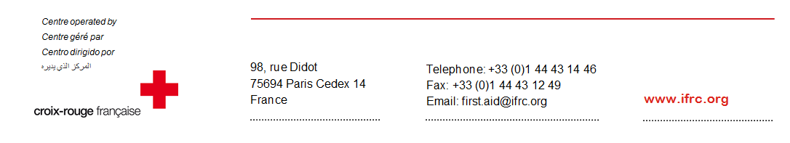**Global results**

In 2015, the Global First Aid Reference Centre, hosted by the First Aid and Emergency department of the French Red Cross, carried out a study on first aid training. 116 National Societies participated in the study.

* For the 116 National Societies that answered:
  + The population was composed of **5 479 520 276** habitants,
  + The number of people who received first aid training by the RC/RC National Societies was **13 429 299**,
  + The number of first aid training personnel for the RC/RC National Societies was **179 959**,
  + The percentage of the population that was trained in first aid by the RC/RC national societies during that year was **1.42%**.
* 50% and 37% of the countries enacted a law which makes compulsory first aid training for, respectively, workers and student nurses. These are the two categories of people for which the most countries have enacted a law making first aid training compulsory. On the contrary, only 16% and 20% of the countries have enacted a law which makes first aid training compulsory for, respectively, schools and employees in senior citizens’ homes.
* In 33% of the countries, there is a law which forces a citizen to act in case of an emergency. The area which holds the most countries with such a law is Europe with 66% of its countries. On the contrary, the Asia-Pacific region with 3% of its countries it’s the area in which countries has enacted the least amount of laws on this subject.
* In 62% of the countries, in case of incorrect action during first aid, a citizen can be sued. The region which has the most countries in this situation is Africa with 86% of its countries. On the contrary, the MENA region with 33% of its countries is the region in which a citizen has the least amount of risk of being sued in case of incorrect action.
* In 38% of the countries, there is a law which makes compulsory the possession of a first aid kit in private vehicles. The region which has the most countries having enacted a law on this subject is the MENA region with 68% of its countries. On the contrary, among the countries of the Asia-Pacific region which have replied to the study, 89% of the countries has a law concerning this subject.
* 85% of the National Societies have a length of validity for their first aid diplomas. 100% of the countries in the MENA region have one, as opposed to 78% of the countries in the African region. In 19% of the countries, the length of validity has been decided by the State. In Europe, it has been decided by the State in 29% of the countries, as opposed to the Aftica and to the Middle-East/North African region where no State has fixed a length of validity for first aid diplomas.
* Regarding the refresher courses, 81% of the countries organize them. 77% organize them in face-to-face, 2% online and 7% do a blended learning. All the countries in the Middle East/North Africa organize the refreshing of knowledge courses, as opposed to 62% of the countries in the Americas.
* In 69% of the countries, the use of AED by non-medical staff is authorized. In 73% of the countries in the Americas, the use of DAE by non-medical staff is authorized as opposed to 50% of the countries in the Middle East/North African region.
* In 69% of the countries, the use of AED by RC/RC volunteers is authorized. In 92% of the countries in the Americas, the use of AED by RC/RC volunteers is authorized, as opposed to 50% of the countries in Africa and in the Middle East/North African region.
* In 22% of the countries there is a State law which regulates AED. 34% of the countries of the European region have a state law which regulates AED, as opposed to the Middle East/African region in which no country regulates AED.
* In 18% of the countries there is a state law which regulates the access to public defibrillation. In 29% of the countries in the European region, there is a state law which regulates public access to defibrillation, as opposed to the Middle-East/North African region and Africa where no country has enacted a law on this subject.
* In 39% of the countries, the general public can have access to AED. In 46% of the countries in the Americas, the general public can have access to AED, as opposed to the African region in which the general public has access to AED in only 21% of the countries.
* 59% of the National Societies participate in the training of the general public to AED. In 83% of the countries in the Middle-East/North African region, the National Societies participate in the training of the general public to AED as opposed to the African region in which only 28% of the National Societies participate to it.